Documentation For Full stack CLI Program.

Group: Jordan,Cameron,Nathan

**Starting the app**

**node myapp :** The user must write the command *node myapp* to start the app and bring up the main menu like the one below

Help Menu

**node myapp –help:**  to bring up the help menu the user must write the command *node myapp –-help****.*** This will display the samemenu as the main

Initilization Section Of The CLI

**myapp init –all :** This command creates the folder structure and the configuration file. It will also create logs for the events when it happens

**node myapp init –mk:** this command just creates the folder structure. We still have the bug where the create all folder log still writes out and we really cant figure it out…

**Node myapp init –cat:** this command just creates the config file and token file with the default settings.. we still cant figure out the bug where the create all files log writes either…. Everything we tried broke the code ….

Configuration Section Of THE CLI

**node myapp config** –show: this command shows the configuration file with all the info for the configuration settings..

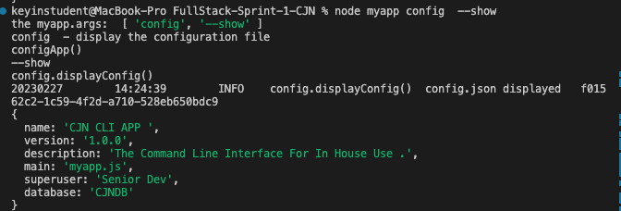

**node myapp config** –reset: this command will reset the config.json file back to its original state.

node myapp config –set: this command will take the input and set it into the config.json file.

Token Section Of The CLI

**node myapp token** –count: this command will display a count of the tokens created.

**node myapp token** –list: this command will display a list with all the usernames of tokens.

**node myapp token**--new <username>: this command will create a new token with the given username and save the token to the json file.

**node myapp token --upd p <username> <phone>:** When typed into the terminal it updates the json entry using the phone number.

**node myapp token --upd e <username> <email>:** When typed into the terminal it updates the entry using the email.

**node myapp token --searchUsername <username>:** When typed into the terminal it searches a token for a given username.

**node myapp token --searchEmail <email>:** When typed into the terminal it searches a token for a given email.

**node myapp token --searchPhone <phone>:** When typed into the terminal it searches a token for given phone.

